Posted 12/5/2011 at 8:50 am by JAV

Municipal Building Committee

Agenda
Old Library, Fireplace Room
Thursday, Dec. 8, 2011
7:00 PM

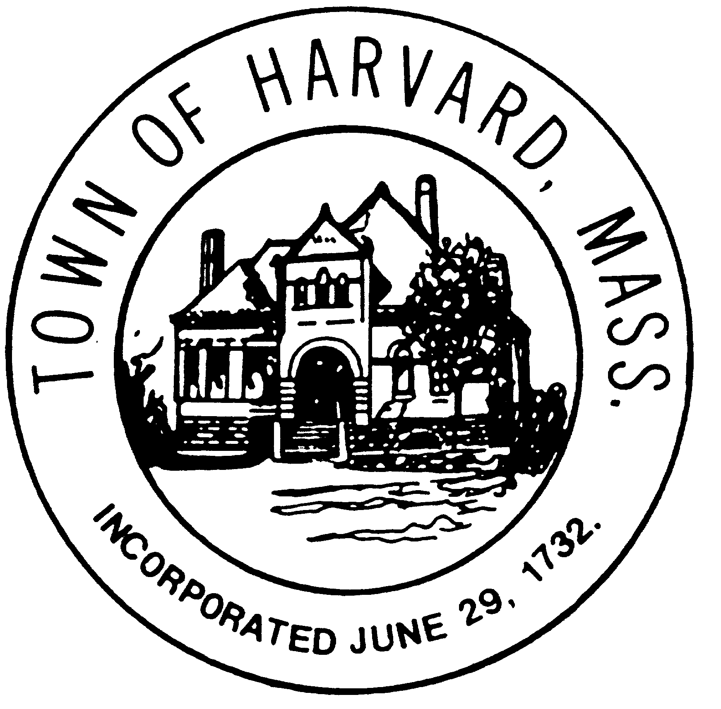
- Approve minutes

- LLB - Review Sketch Layouts

- DTI - Schedule and Budget update

- Preparation for Public Meeting on Dec. 14

- Agenda for next meeting

